NAME OF APP

Logan Mooney, Jade Glasgow, Thomas Harris, Tony Robinson, Safa Asadi

[name of app] is a modern take on the traditional meal-planning application. The goal of our app is to provide college students and young adults with an easy way to plan meals while using ingredients they already have at home. This app will make it easy for young, single adults to cook for themselves, while also reducing food waste. [name of app] is a mobile app that keeps track of what food people already have at home and gives recipe suggestions based off those ingredients. [name of app] also acts as grocery list -- once the user indicates that they bought an item, [name of app] adds the item to the user’s virtual pantry. Finally, [name of app] keeps track of the shelf life of each item in the user’s pantry. This feature encourages users to use food before it spoils, thus reducing waste.

# THE PROBLEM

There is a problem many college students and busy families run in and that

is the grocery store dilemma. Many times we will absent mindedly go into a store

and purchase random items that don’t form a specific meal. Other times we’ll have

the perfect ingredients in our fridge that can form into a meal but we don’t have the

recipes to know what to make. go into the store and forget what we have in the

pantry and repurchase that item. Many items go to waste as they do not get used up

in time before the expiration dates. And there’s also the issue with not knowing

when the expiration dates are in your pantry when you’re at the grocery store.

In a study focused on University residence and their eating habits, the study

states “The majority of the participants did not consider the nutritional value

while consuming a particular food item. They even admitted that they did not

have good knowledge about the nutritional value of the food they commonly eat

as part of their daily meals” (Kabir, 2018). This shows how little knowledge

students have in what they are putting into their bodies simply from the active and

busy lifestyle of college students. Furthermore, many households are found

throwing away items because they went bad before being prepared. In this study it

was found that households threw away greater quantities of unprepared food in

the 48-hour recall period (268.6±610.1 g, 90% confidence interval: 175.5 to 361.7

g) compared to prepared food (121.0±132.4 g, 90% confidence interval: 100.8 to

141.3 g) (Chakona, 2018).

# OUR SOLUTION

These problems can be solved with a mobile grocery store app that takes

care of it for you. The app keeps track of what food people already have at home

and gives suggestions for recipes that use those ingredients. Recipes will include

calorie and nutrition facts to help busy students and families with healthier eating

habits that also makes the best use out of your pantry. It also acts like a grocery list

for when you are out shopping which helps with over-spending or under

purchasing items. Your virtual pantry saves items every time a grocery list item is

crossed off on the app. With a barcode scanner you can keep track of the shelf life

so when you’re at the grocery store you know when

# USERS

**Target Users**

The target users for our application are primarily college students and young adults. Other users who may find the app useful are working parents or single adults who have little time to cook and plan meals.

This is an appropriate target group because many college students are having to cook for themselves for the first time. They are also only cooking for one person, which presents many challenges. The app will help them use the food they have in their fridge before it goes bad and give suggestions for new recipes. Working parents or single adults may also find this useful. Working parents are often short on time, so it is useful to have an app to plan and track meals. SIngle adults, like college students, share the challenges that come with cooking for one person.



**Non-Target Users**

Anyone below college-age (~18), senior citizens, people who don’t cook for themselves

In order to verify these assumptions, our team conducted a series of interviews that focused on our target user groups. The results of our user research are detailed below.

# USER RESEARCH

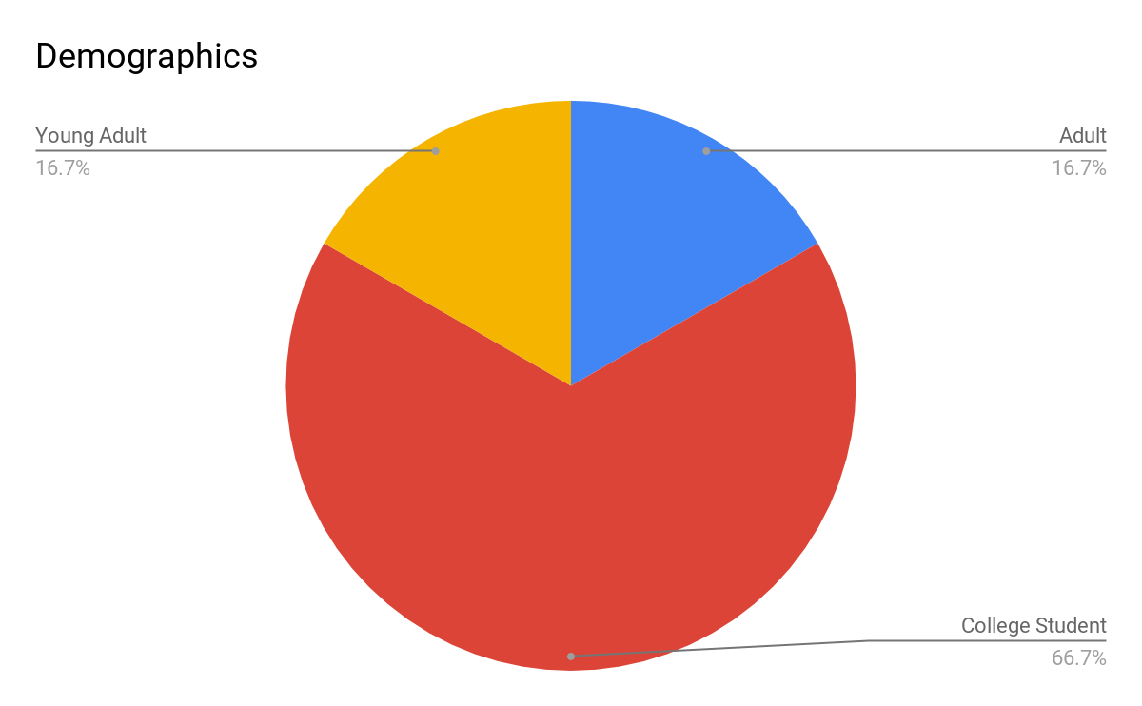

# Points scoredPoints scored

The above data confirmed our assumptions that college students and young adults would be the primary beneficiaries from this application. Older, single adults could also benefit from the app, but parents who cook for multiple people daily are not likely to use the app. Our research showed that parents rarely had food go bad in their fridges, but almost all college students suffered from frequent food spoilage. Every potential user that we interviewed cooked for themselves at least twice a week, but most users cooked for themselves almost every day or every day.

# PERSONA

# 

# TASK ANALYSIS

**Are these mobile users, desktop users, people in the library, etc?**

The users would be mobile. Reason being that they are going to use this app on the move, keeping track of food they eat/get from stores.

**What geographic area are the users in? How does this impact them?**

Users can be almost anywhere with a internet or cellular connection. They need a connection to use an app so they can't be out of range. They also need to be able to shop at a grocery store or local market.

**What is the age range of the users? Does that impact things?**

This app is primarily for college aged individuals, but also works for young to older adults who don't have time to make meals due to money, time, etc.

**What are the implications of economic standing?**

Users at least need to be able to obtain bare minimum when grocery shopping. (Ex. Milk, Bread, deli meats)

**HTA for getting recipes from the app**

* + - Task 1: Getting recipes from app.
      * 1.1 open app
      * 1.2 open pantry/fridge
      * 1.3 log food found in pantry/fridge
      * 1.4 look at recipes provided for current food logged
      * 1.5 Find recipes that fit what they have available

**HTA for tracking food purchases on the app**

* + - Task 2: Tracking food purchases on the app.
      * 2.1 go to local grocery store
      * 2.2 open app while you are shopping
      * 2.3 search for food to satisfy a current recipe or get food and see what recipes will fit what you bought
      * 2.4 As you pick up food, scan it so that it can be logged into the app
      * 2.5 search for recipes already loaded into the app or new ones that will fit what you bought

# EXISTING SOLUTIONS

There are a few different apps for tracking food you have in your fridge, including RecipEase, MyKURA, and Out of Milk. There are also some apps for finding recipes based on what you currently have in your pantry, like SuperCook and MyFridge. However, we couldn’t find any apps that combined the two functions. Even RecipEase, which contained a function to search for recipes didn’t allow you to search based on what you had in your pantry.

**Food Tracking Apps**

RecipEase

Each of the apps had a different method of entering items automatically. RecipEase takes a picture of your receipt and automatically adds the items to your pantry. It even tries to categorize items based on where they would belong (i.e. eggs in the fridge) and include expiration dates. This worked well for some items, but receipts generally include discounts and items that aren’t immediately identifiable (e.g. I bought soap that was listed as “pear coconut” and was placed in the pantry by the app). 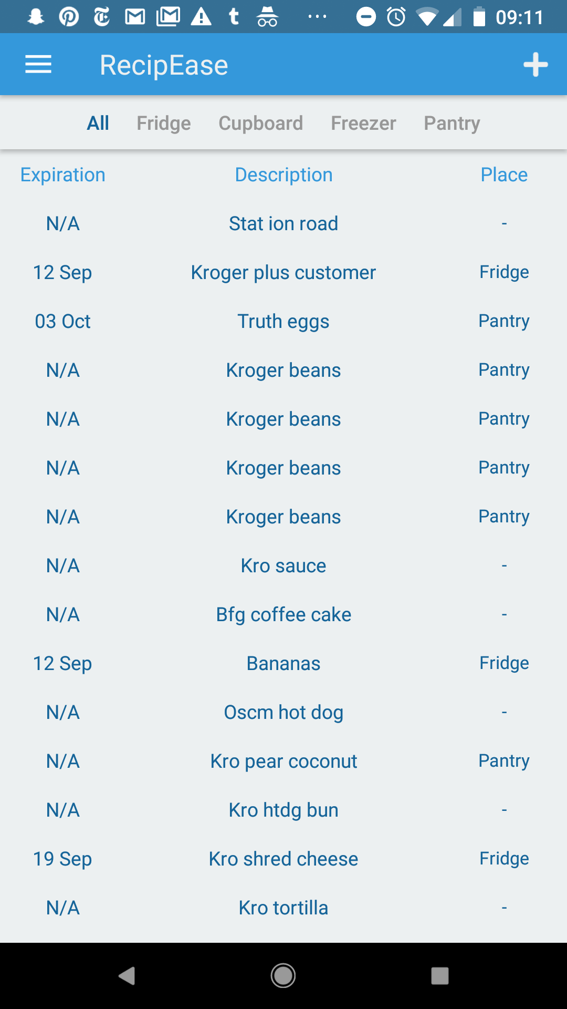

There is also an option to enter items manually, which takes the form of a text box at the end of your current list where you can enter an item name like and go back later and add an expiration date and a location where the item is kept. I appreciated this method of manually entering information because it didn’t take the user away from the page they were looking at, and it would make it faster to add items to the list. Adding an expiration date to the item was also easy. The app pops up a calendar view to easily add a date. One issue I saw in the process is that adding an item to a location involved a very small drop down menu that wouldn’t be very easy to select from. 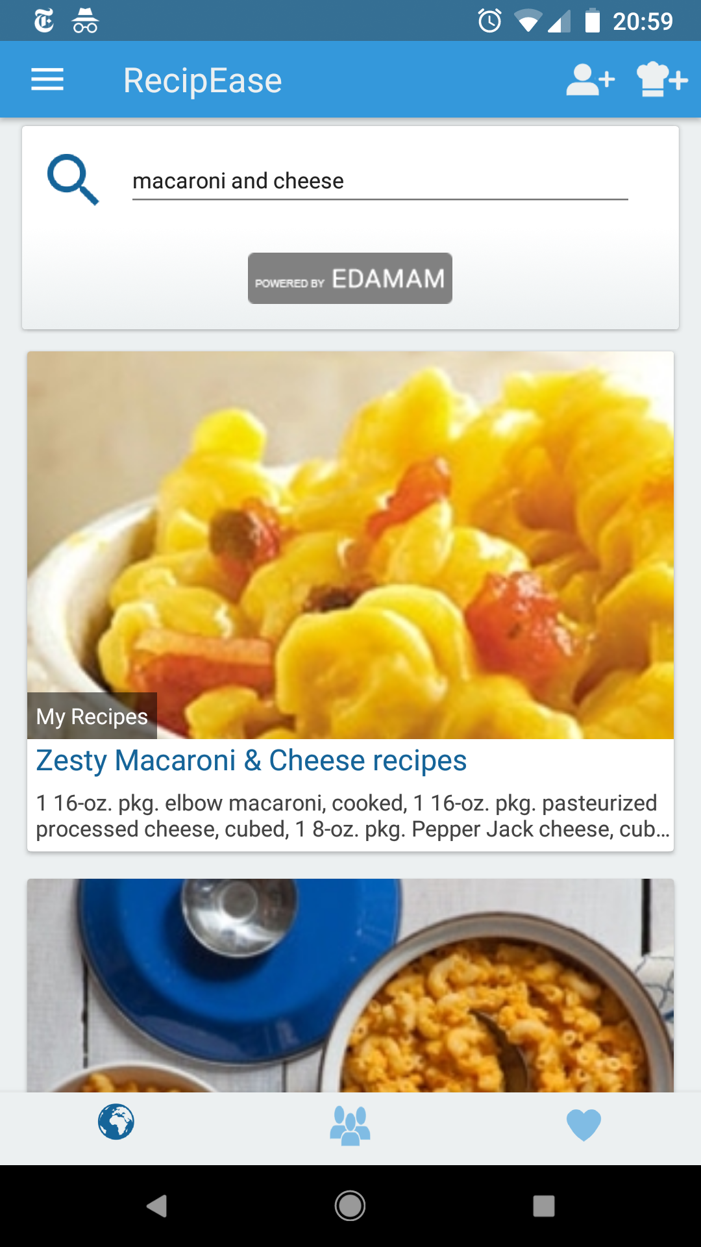

In terms of displaying information, the app is pretty bare bones. It simply has a list of the items you have in your pantry, shown with the expiration date and location. It includes tabs to view each item individually, allowing a user to see only the items in their freezer for example, which would help narrow down the items a user is looking at. It does seem like looking through this list would get cumbersome. There isn’t a way for users to quickly check whether they have a specific product without reading each individual item name. This is especially difficult if a user entered the item names automatically, as the names on receipts aren’t always intuitive.

Out of Milk

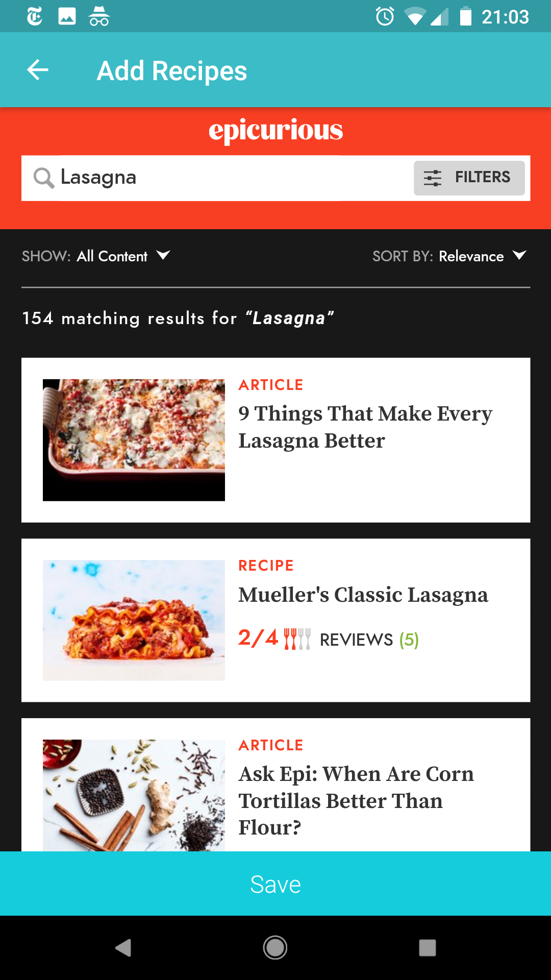

Out of Milk includes a barcode scanner in order to automatically enter items, which was very convenient. It also allowed users to quickly add items by just typing in the name rather than going through the whole form process. Unlike in RecipEase, this name was added at the top rather than the bottom, which made it more enjoyable to use since there was no scrolling required to access the add item function. The app also allowed a user to mark whether the item was “full” or “low”, which could be helpful in determining when to buy more.

Out of Milk also had a much more intuitive way of displaying information. Items were displayed by color-coded category rather than location, which would allow for a more intuitive way to find the ones you’re looking for. For example, if a user wanted to know if they had milk, they would search through the items in the dairy category rather than reading through everything in the fridge. Categories of common things like “eggs” were automatically included, though a user could also tap an item to be brought to a form where they could manually select it. 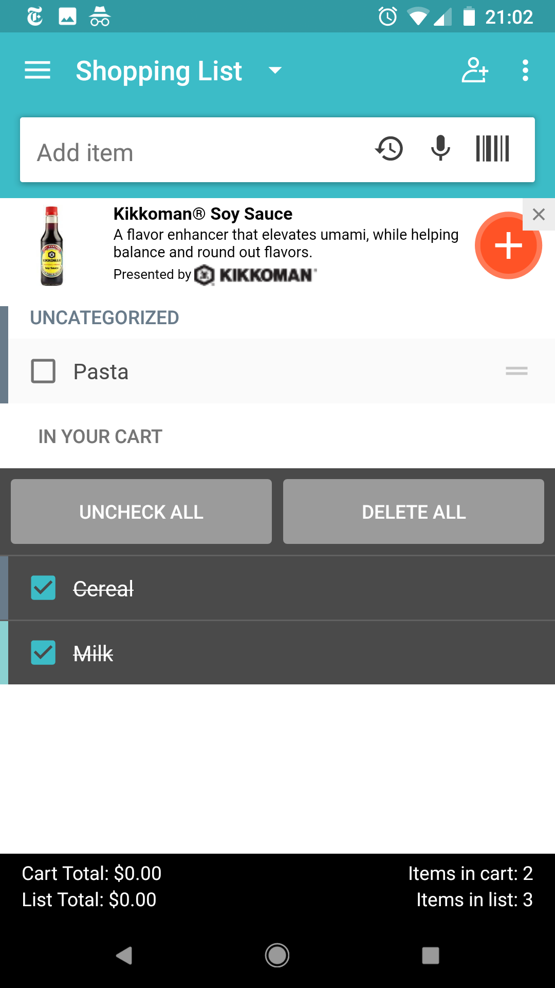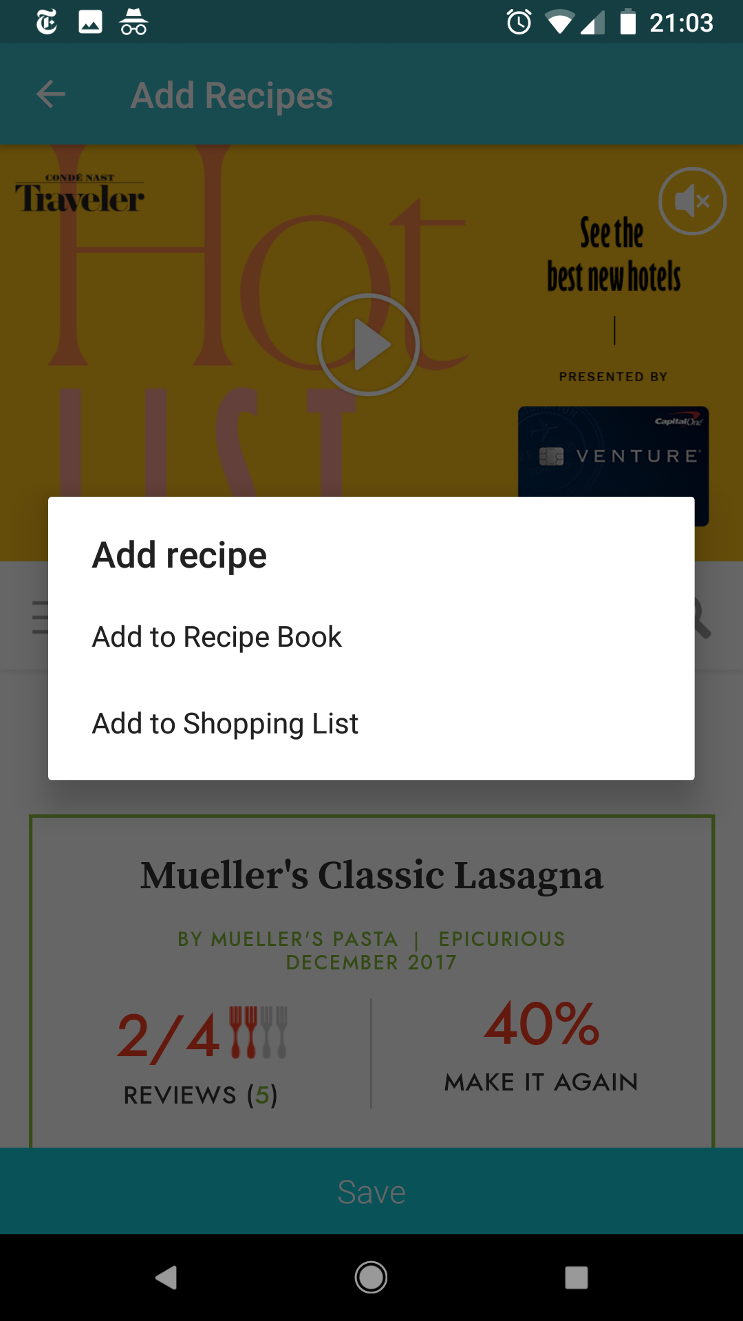

One feature that was particularly helpful in Out of Milk was the ability to automatically add items to a shopping list. Each item in your pantry list had a check box next to it that could be checked in order to send an item to your shopping list, which was also divided up by category to make shopping easier. It was also possible to add things to the shopping list in the same way as adding items to the pantry.

MyKURA

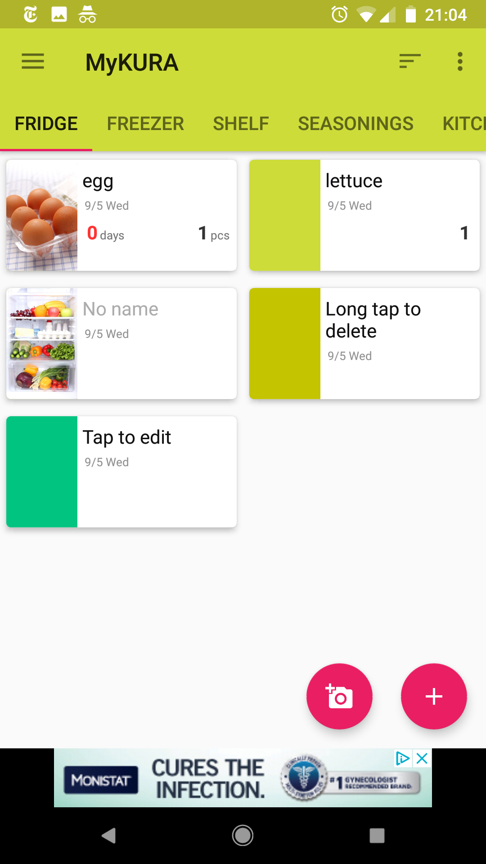

MyKURA was set up by location rather than category, like RecipEase, and it didn’t include a shopping list function. The one thing I really liked about it was that it included a function to take pictures of your items, which lets a user see the foods they have rather than just being able to read the names. Items can be added with only a picture, only a name, or both a picture and a name. Users can also manually color-code their food if they don’t want to include pictures.

**Recipe Search Apps**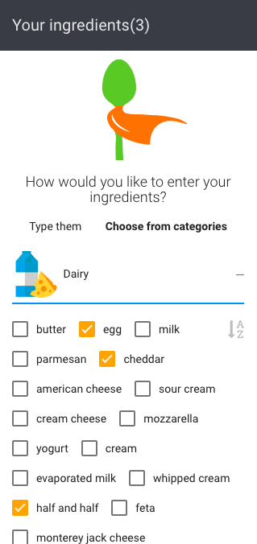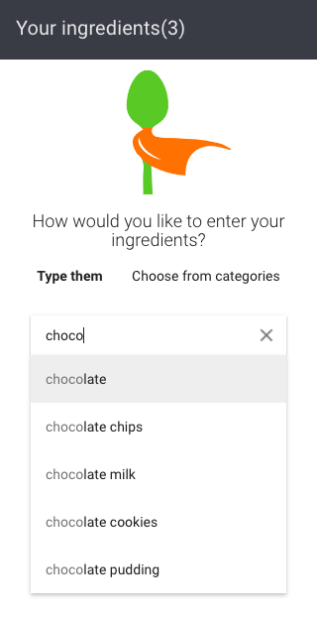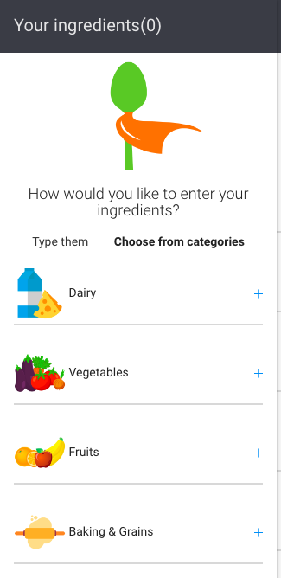

There are a few different apps to search for recipes based on the food you already have. To use them, a user scrolls through a list of items and checks the boxes next to the ones they already have. They then click submit and the app finds recipes that use only items they have or items they have plus a couple extras. 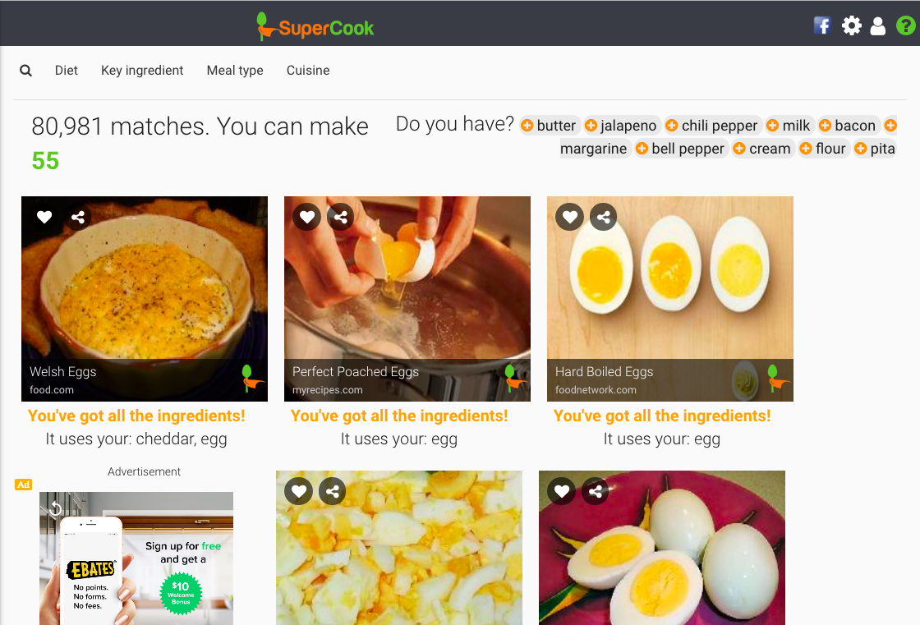

MyFridge allows a user to search for a specific category of recipe rather than just searching for any recipe that includes their ingredients, which was a nice feature.

**Conclusion**

There were some features in these apps that worked very well, and some that were cumbersome to use. After trying out the various apps available on the market now, I would include a feature to track the expiration dates of your foods as well as categorizing foods by type rather than location. Our goal to include both a shopping list function and a recipe search function would fill a niche I don’t see filled right now by allowing users to combine the functionality of something like Out of Milk with an app like MyFridge and reduce the time and memory necessary to use both of these apps separately.

# SUMMARY AND NEXT STEPS

# REFERENCES

Chakona, Gamuchirai, and Charlie M. Shackleton. “Local Setting Influences the Quantity of Household Food Waste in Mid-Sized South African Towns.” Ed. Robert Nerenberg. PLoS ONE 12.12 (2017): e0189407. PMC. Web. 5 Sept. 2018.

Kabir, Ashraful, and Shahgahan Miah. “Factors Influencing Eating Behavior and Dietary Intake among Resident Students in a Public University in Bangladesh: A Qualitative Study.” PLOS Medicine, Public Library of Science, 2018, journals.plos.org/plosone/article?id=10.1371%2Fjournal.pone.0198801.